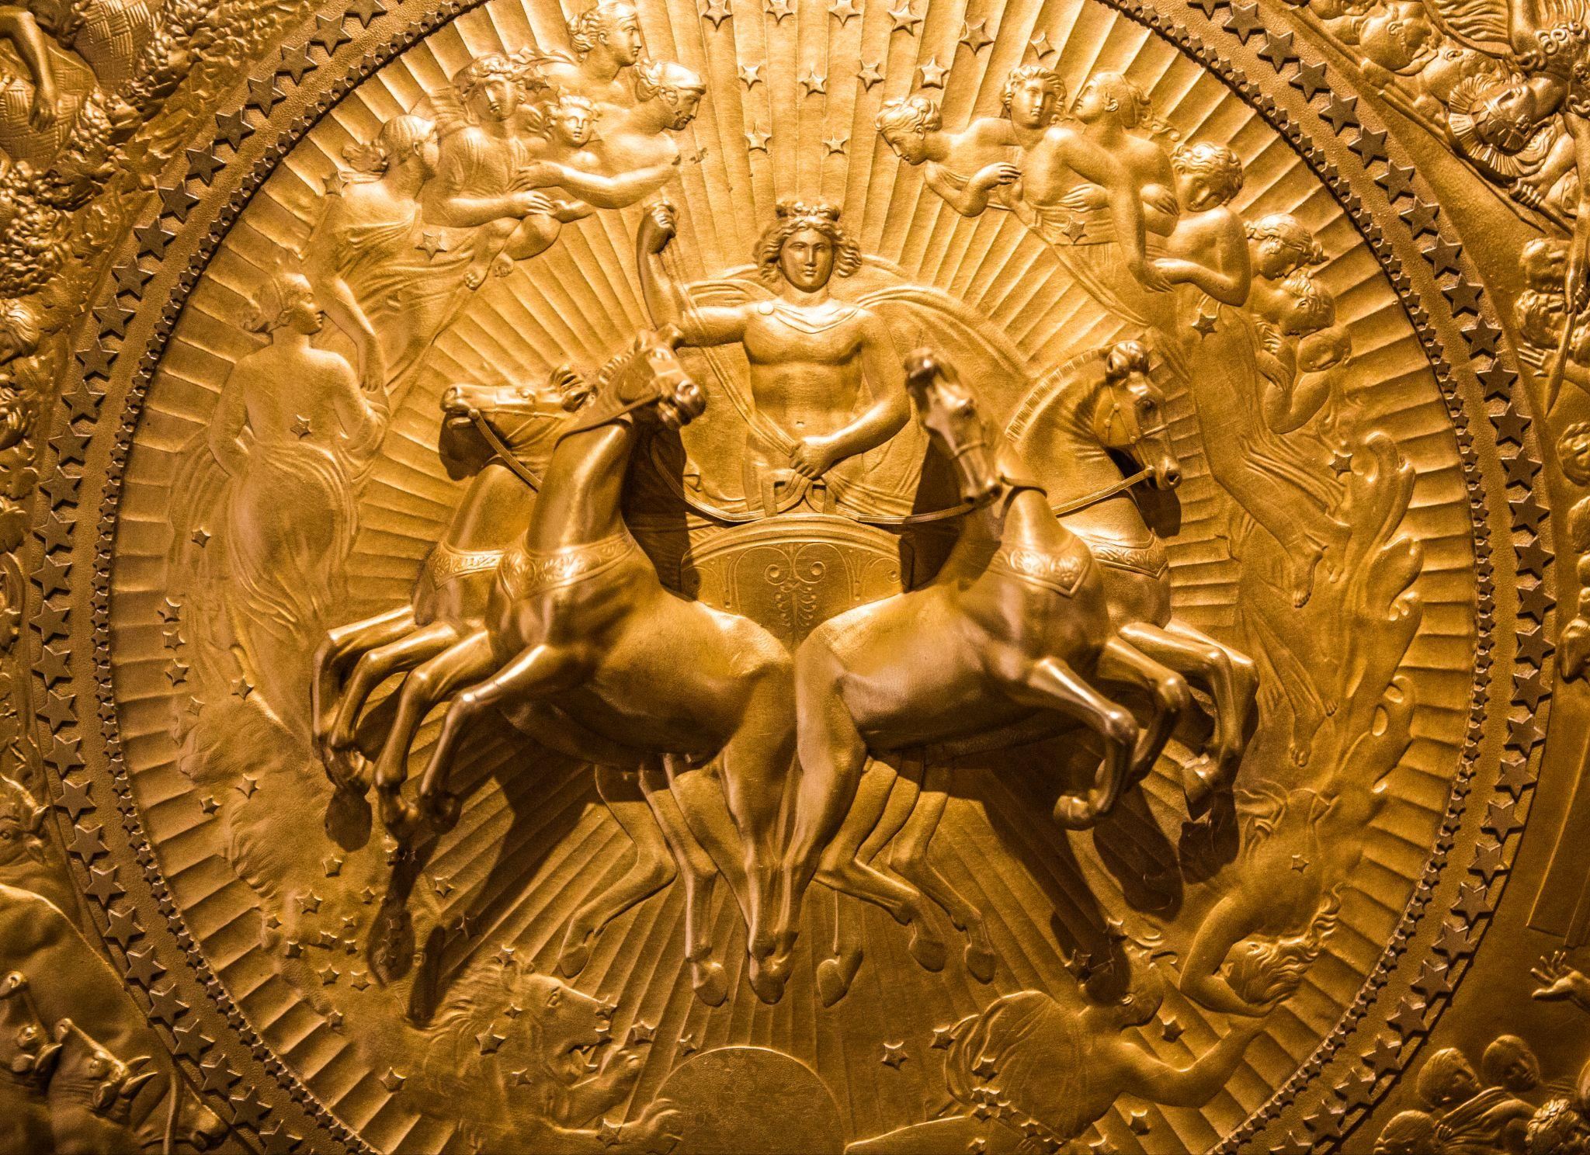

A close-up view of John Flaxman’s 1822 design of the Shield of Achilles, manufactured by Rundell, Bridge, and Rundell. Image taken by Thomas Hawk. Image licensed under CC BY-NC 2.0 DEED Attribution-NonCommercial 2.0 Generic.

The Iliad: The Forging of Achilles’ Shield

Original Greek by Homer

English translation by Samuel Butler, 1898

# Alexander Pope’s Poetic Version

## The Iliad, Book XVIII, The Shield of Achilles

### By Homer (8th century BCE)

### Translated into English by Alexander Pope (1688-1744)

*Thetis goes to the palace of Vulcan to obtain new arms for her son.*

"Thee, welcome, goddess! what occasion calls

(So long a stranger) to these honour'd walls?

'Tis thine, fair Thetis, the command to lay,

And Vulcan's joy and duty to obey."

To whom the mournful mother thus replies:

(The crystal drops stood trembling in her eyes:)

"O Vulcan! say, was ever breast divine

So pierced with sorrows, so o'erwhelm'd as mine?

Of all the goddesses, did Jove prepare

For Thetis only such a weight of care?

I, only I, of all the watery race

By force subjected to a man's embrace,

Who, sinking now with age and sorrow, pays

The mighty fine imposed on length of days.

Sprung from my bed, a godlike hero came,

The bravest sure that ever bore the name;

Like some fair plant beneath my careful hand

He grew, he flourish'd, and he graced the land:

To Troy I sent him! but his native shore

Never, ah never, shall receive him more;

(Even while he lives, he wastes with secret woe;)

Nor I, a goddess, can retard the blow!

Robb'd of the prize the Grecian suffrage gave,

The king of nations forced his royal slave:

For this he grieved; and, till the Greeks oppress'd

Required his arm, he sorrow'd unredress'd.

Large gifts they promise, and their elders send;

In vain--he arms not, but permits his friend

His arms, his steeds, his forces to employ:

He marches, combats, almost conquers Troy:

Then slain by Phoebus (Hector had the name)

At once resigns his armour, life, and fame.

But thou, in pity, by my prayer be won:

Grace with immortal arms this short-lived son,

And to the field in martial pomp restore,

To shine with glory, till he shines no more!"

To her the artist-god: "Thy griefs resign,

Secure, what Vulcan can, is ever thine.

O could I hide him from the Fates, as well,

Or with these hands the cruel stroke repel,

As I shall forge most envied arms, the gaze

Of wondering ages, and the world's amaze!"

Thus having said, the father of the fires

To the black labours of his forge retires.

Soon as he bade them blow, the bellows turn'd

Their iron mouths; and where the furnace burn'd,

Resounding breathed: at once the blast expires,

And twenty forges catch at once the fires;

Just as the god directs, now loud, now low,

They raise a tempest, or they gently blow;

In hissing flames huge silver bars are roll'd,

And stubborn brass, and tin, and solid gold;

Before, deep fix'd, the eternal anvils stand;

The ponderous hammer loads his better hand,

His left with tongs turns the vex'd metal round,

And thick, strong strokes, the doubling vaults rebound.

Then first he form'd the immense and solid shield;

Rich various artifice emblazed the field;

Its utmost verge a threefold circle bound;

A silver chain suspends the massy round;

Five ample plates the broad expanse compose,

And godlike labours on the surface rose.

There shone the image of the master-mind:

There earth, there heaven, there ocean he design'd;

The unwearied sun, the moon completely round;

The starry lights that heaven's high convex crown'd;

The Pleiads, Hyads, with the northern team;

And great Orion's more refulgent beam;

To which, around the axle of the sky,

The Bear, revolving, points his golden eye,

Still shines exalted on the ethereal plain,

Nor bathes his blazing forehead in the main.

Two cities radiant on the shield appear,

The image one of peace, and one of war.

Here sacred pomp and genial feast delight,

And solemn dance, and hymeneal rite;

Along the street the new-made brides are led,

With torches flaming, to the nuptial bed:

The youthful dancers in a circle bound

To the soft flute, and cithern's silver sound:

Through the fair streets the matrons in a row

Stand in their porches, and enjoy the show.

There in the forum swarm a numerous train;

The subject of debate, a townsman slain:

One pleads the fine discharged, which one denied,

And bade the public and the laws decide:

The witness is produced on either hand:

For this, or that, the partial people stand:

The appointed heralds still the noisy bands,

And form a ring, with sceptres in their hands:

On seats of stone, within the sacred place,

The reverend elders nodded o'er the case;

Alternate, each the attesting sceptre took,

And rising solemn, each his sentence spoke

Two golden talents lay amidst, in sight,

The prize of him who best adjudged the right.

Another part (a prospect differing far)(255)

Glow'd with refulgent arms, and horrid war.

Two mighty hosts a leaguer'd town embrace,

And one would pillage, one would burn the place.

Meantime the townsmen, arm'd with silent care,

A secret ambush on the foe prepare:

Their wives, their children, and the watchful band

Of trembling parents, on the turrets stand.

They march; by Pallas and by Mars made bold:

Gold were the gods, their radiant garments gold,

And gold their armour: these the squadron led,

August, divine, superior by the head!

A place for ambush fit they found, and stood,

Cover'd with shields, beside a silver flood.

Two spies at distance lurk, and watchful seem

If sheep or oxen seek the winding stream.

Soon the white flocks proceeded o'er the plains,

And steers slow-moving, and two shepherd swains;

Behind them piping on their reeds they go,

Nor fear an ambush, nor suspect a foe.

In arms the glittering squadron rising round

Rush sudden; hills of slaughter heap the ground;

Whole flocks and herds lie bleeding on the plains,

And, all amidst them, dead, the shepherd swains!

The bellowing oxen the besiegers hear;

They rise, take horse, approach, and meet the war,

They fight, they fall, beside the silver flood;

The waving silver seem'd to blush with blood.

There Tumult, there Contention stood confess'd;

One rear'd a dagger at a captive's breast;

One held a living foe, that freshly bled

With new-made wounds; another dragg'd a dead;

Now here, now there, the carcases they tore:

Fate stalk'd amidst them, grim with human gore.

And the whole war came out, and met the eye;

And each bold figure seem'd to live or die.

A field deep furrow'd next the god design'd,

The third time labour'd by the sweating hind;

The shining shares full many ploughmen guide,

And turn their crooked yokes on every side.

Still as at either end they wheel around,

The master meets them with his goblet crown'd;

The hearty draught rewards, renews their toil,

Then back the turning ploughshares cleave the soil:

Behind, the rising earth in ridges roll'd;

And sable look'd, though form'd of molten gold.

Another field rose high with waving grain;

With bended sickles stand the reaper train:

Here stretched in ranks the levell'd swarths are found,

Sheaves heap'd on sheaves here thicken up the ground.

With sweeping stroke the mowers strow the lands;

The gatherers follow, and collect in bands;

And last the children, in whose arms are borne

(Too short to gripe them) the brown sheaves of corn.

The rustic monarch of the field descries,

With silent glee, the heaps around him rise.

A ready banquet on the turf is laid,

Beneath an ample oak's expanded shade.

The victim ox the sturdy youth prepare;

The reaper's due repast, the woman's care.

Next, ripe in yellow gold, a vineyard shines,

Bent with the ponderous harvest of its vines;

A deeper dye the dangling clusters show,

And curl'd on silver props, in order glow:

A darker metal mix'd intrench'd the place;

And pales of glittering tin the inclosure grace.

To this, one pathway gently winding leads,

Where march a train with baskets on their heads,

(Fair maids and blooming youths,) that smiling bear

The purple product of the autumnal year.

To these a youth awakes the warbling strings,

Whose tender lay the fate of Linus sings;

In measured dance behind him move the train,

Tune soft the voice, and answer to the strain.

Here herds of oxen march, erect and bold,

Rear high their horns, and seem to low in gold,

And speed to meadows on whose sounding shores

A rapid torrent through the rushes roars:

Four golden herdsmen as their guardians stand,

And nine sour dogs complete the rustic band.

Two lions rushing from the wood appear'd;

And seized a bull, the master of the herd:

He roar'd: in vain the dogs, the men withstood;

They tore his flesh, and drank his sable blood.

The dogs (oft cheer'd in vain) desert the prey,

Dread the grim terrors, and at distance bay.

Next this, the eye the art of Vulcan leads

Deep through fair forests, and a length of meads,

And stalls, and folds, and scatter'd cots between;

And fleecy flocks, that whiten all the scene.

A figured dance succeeds; such once was seen

In lofty Gnossus for the Cretan queen,

Form'd by Daedalean art; a comely band

Of youths and maidens, bounding hand in hand.

The maids in soft simars of linen dress'd;

The youths all graceful in the glossy vest:

Of those the locks with flowery wreath inroll'd;

Of these the sides adorn'd with swords of gold,

That glittering gay, from silver belts depend.

Now all at once they rise, at once descend,

With well-taught feet: now shape in oblique ways,

Confusedly regular, the moving maze:

Now forth at once, too swift for sight, they spring,

And undistinguish'd blend the flying ring:

So whirls a wheel, in giddy circle toss'd,

And, rapid as it runs, the single spokes are lost.

The gazing multitudes admire around:

Two active tumblers in the centre bound;

Now high, now low, their pliant limbs they bend:

And general songs the sprightly revel end.

Thus the broad shield complete the artist crown'd

With his last hand, and pour'd the ocean round:

In living silver seem'd the waves to roll,

And beat the buckler's verge, and bound the whole.

This done, whate'er a warrior's use requires

He forged; the cuirass that outshone the fires,

The greaves of ductile tin, the helm impress'd

With various sculpture, and the golden crest.

At Thetis' feet the finished labour lay:

She, as a falcon cuts the aerial way,

Swift from Olympus' snowy summit flies,

And bears the blazing present through the skies.

# Samuel Butler’s Prose Version

## The Iliad, Book XVIII, lines 464-615:

### By Homer (8th century BCE)

### Translated into English by Samuel Butler (1835-1902)

When he had so said he left her and went to his bellows, turning them towards the fire and bidding them do their office. Twenty bellows blew upon the melting-pots, and they blew blasts of every kind, some fierce to help him when he had need of them, and others less strong as Hephaistos willed it in the course of his work. He threw tough copper into the fire, and tin, with silver and gold; he set his great anvil on its block, and with one hand grasped his mighty hammer while he took the tongs in the other.

First he shaped the shield so great and strong, adorning it all over and binding it round with a gleaming circuit in three layers; and the baldric was made of silver. He made the shield in five thicknesses, and with many a wonder did his cunning hand enrich it.

He wrought the earth, the heavens, and the sea; the moon also at her full and the untiring sun, with all the signs that glorify the face of heaven - the Pleiads, the Hyads, huge Orion, and the Bear, which men also call the Wain and which turns round ever in one place, facing. Orion, and alone never dips into the stream of Okeanos.

He wrought also two cities, fair to see and busy with the hum of men. In the one were weddings and wedding-feasts, and they were going about the city with brides whom they were escorting by torchlight from their chambers. Loud rose the cry of Hymen, and the youths danced to the music of flute and lyre, while the women stood each at her house door to see them.

Meanwhile the people were gathered in assembly, for there was a quarrel, and two men were wrangling about the blood-price for a man who had died, the one claiming to the dêmos that he had the right to pay off the damages in full, and the other refusing to accept anything. Each was seeking a limit, in the presence of an arbitrator, and the people took sides, each man backing the side that he had taken;

but the heralds kept them back, and the elders sat on their seats of stone in a solemn circle, holding the staves which the heralds had put into their hands. Then they rose and each in his turn gave judgment, and there were two measures of gold laid down, to be given to him whose judgment should be deemed the fairest.

About the other city there lay encamped two hosts in gleaming armor, and they were divided whether to sack it, or to spare it and accept the half of what it contained. But the men of the city would not yet consent, and armed themselves for a surprise; their wives and little children kept guard upon the walls, and with them were the men who were past fighting through age; but the others sallied forth with Ares and Pallas Athena at their head - both of them wrought in gold and clad in golden raiment, great and fair with their armor as befitting gods, while they that followed were smaller. When they reached the place where they would lay their ambush, it was on a riverbed to which live stock of all kinds would come from far and near to water; here, then, they lay concealed, clad in full armor. Some way off them there were two scouts who were on the look-out for the coming of sheep or cattle, which presently came, followed by two shepherds who were playing on their pipes, and had not so much as a thought of danger. When those who were in ambush saw this, they cut off the flocks and herds and killed the shepherds. Meanwhile the besiegers, when they heard much noise among the cattle as they sat in council, sprang to their horses, and made with all speed towards them; when they reached them they set battle in array by the banks of the river, and the hosts aimed their bronze-shod spears at one another. With them were Strife and Riot, and fell Fate who was dragging three men after her, one with a fresh wound, and the other unwounded, while the third was dead, and she was dragging him along by his heel: and her robe was bedrabbled in men's blood. They went in and out with one another and fought as though they were living people haling away one another's dead.

He wrought also a fair fallow field, large and thrice ploughed already. Many men were working at the plough within it, turning their oxen to and fro, furrow after furrow. Each time that they turned on reaching the headland a man would come up to them and give them a cup of wine, and they would go back to their furrows looking forward to the time when they should again reach the headland. The part that they had ploughed was dark behind them, so that the field, though it was of gold, still looked as if it were being ploughed - very curious to behold.

He wrought also a field of harvest grain, and the reapers were reaping with sharp sickles in their hands. Swathe after swathe fell to the ground in a straight line behind them, and the binders bound them in bands of twisted straw. There were three binders, and behind them there were boys who gathered the cut grain in armfuls and kept on bringing them to be bound: among them all the owner of the land stood by in silence and was glad. The servants were getting a meal ready under an oak, for they had sacrificed a great ox, and were busy cutting him up, while the women were making a porridge of much white barley for the laborers' dinner.

He wrought also a vineyard, golden and fair to see, and the vines were loaded with grapes. The bunches overhead were black, but the vines were trained on poles of silver. He ran a ditch of dark metal all round it, and fenced it with a fence of tin; there was only one path to it, and by this the vintagers went when they would gather the vintage. Youths and maidens all blithe and full of glee, carried the luscious fruit in plaited baskets; and with them there went a boy who made sweet music with his lyre, and sang the Linus-song with his clear boyish voice.

He wrought also a herd of horned cattle. He made the cows of gold and tin, and they lowed as they came full speed out of the yards to go and feed among the waving reeds that grow by the banks of the river. Along with the cattle there went four shepherds, all of them in gold, and their nine fleet dogs went with them. Two terrible lions had fastened on a bellowing bull that was with the foremost cows, and bellow as he might they haled him, while the dogs and men gave chase: the lions tore through the bull's thick hide and were gorging on his blood and bowels, but the herdsmen were afraid to do anything, and only hounded on their dogs; the dogs dared not fasten on the lions but stood by barking and keeping out of harm's way.

The god wrought also a pasture in a fair mountain dell, and large flock of sheep, with a homestead and huts, and sheltered sheepfolds.

Furthermore he wrought a green, like that which Daedalus once made in Knossos for lovely Ariadne. Here was a dance [khoros] of youths and maidens, whom all would woo, all with their hands on one another's wrists. The maidens wore robes of light linen, and the youths well woven shirts that were slightly oiled. The girls were crowned with garlands, while the young men had daggers of gold that hung by silver baldrics; sometimes they would dance deftly in a ring with merry twinkling feet, as it were a potter sitting at his work and making trial of his wheel to see whether it will run, and sometimes they would go all in line with one another, and many people was gathered joyously about the place of dancing. There was a bard also to sing to them and play his lyre, while two tumblers went about performing in the midst of them when the man struck up with his tune.

All round the outermost rim of the shield he set the mighty stream of the river Okeanos.

Then when he had fashioned the shield so great and strong, he made a breastplate also that shone brighter than fire. He made helmet, close fitting to the brow, and richly worked, with a golden plume overhanging it; and he made greaves also of beaten tin.

Lastly, when the famed lame god had made all the armor, he took it and set it before the mother of Achilles; whereon she darted like a falcon from the snowy summits of Olympus and bore away the gleaming armor from the house of Hephaistos.

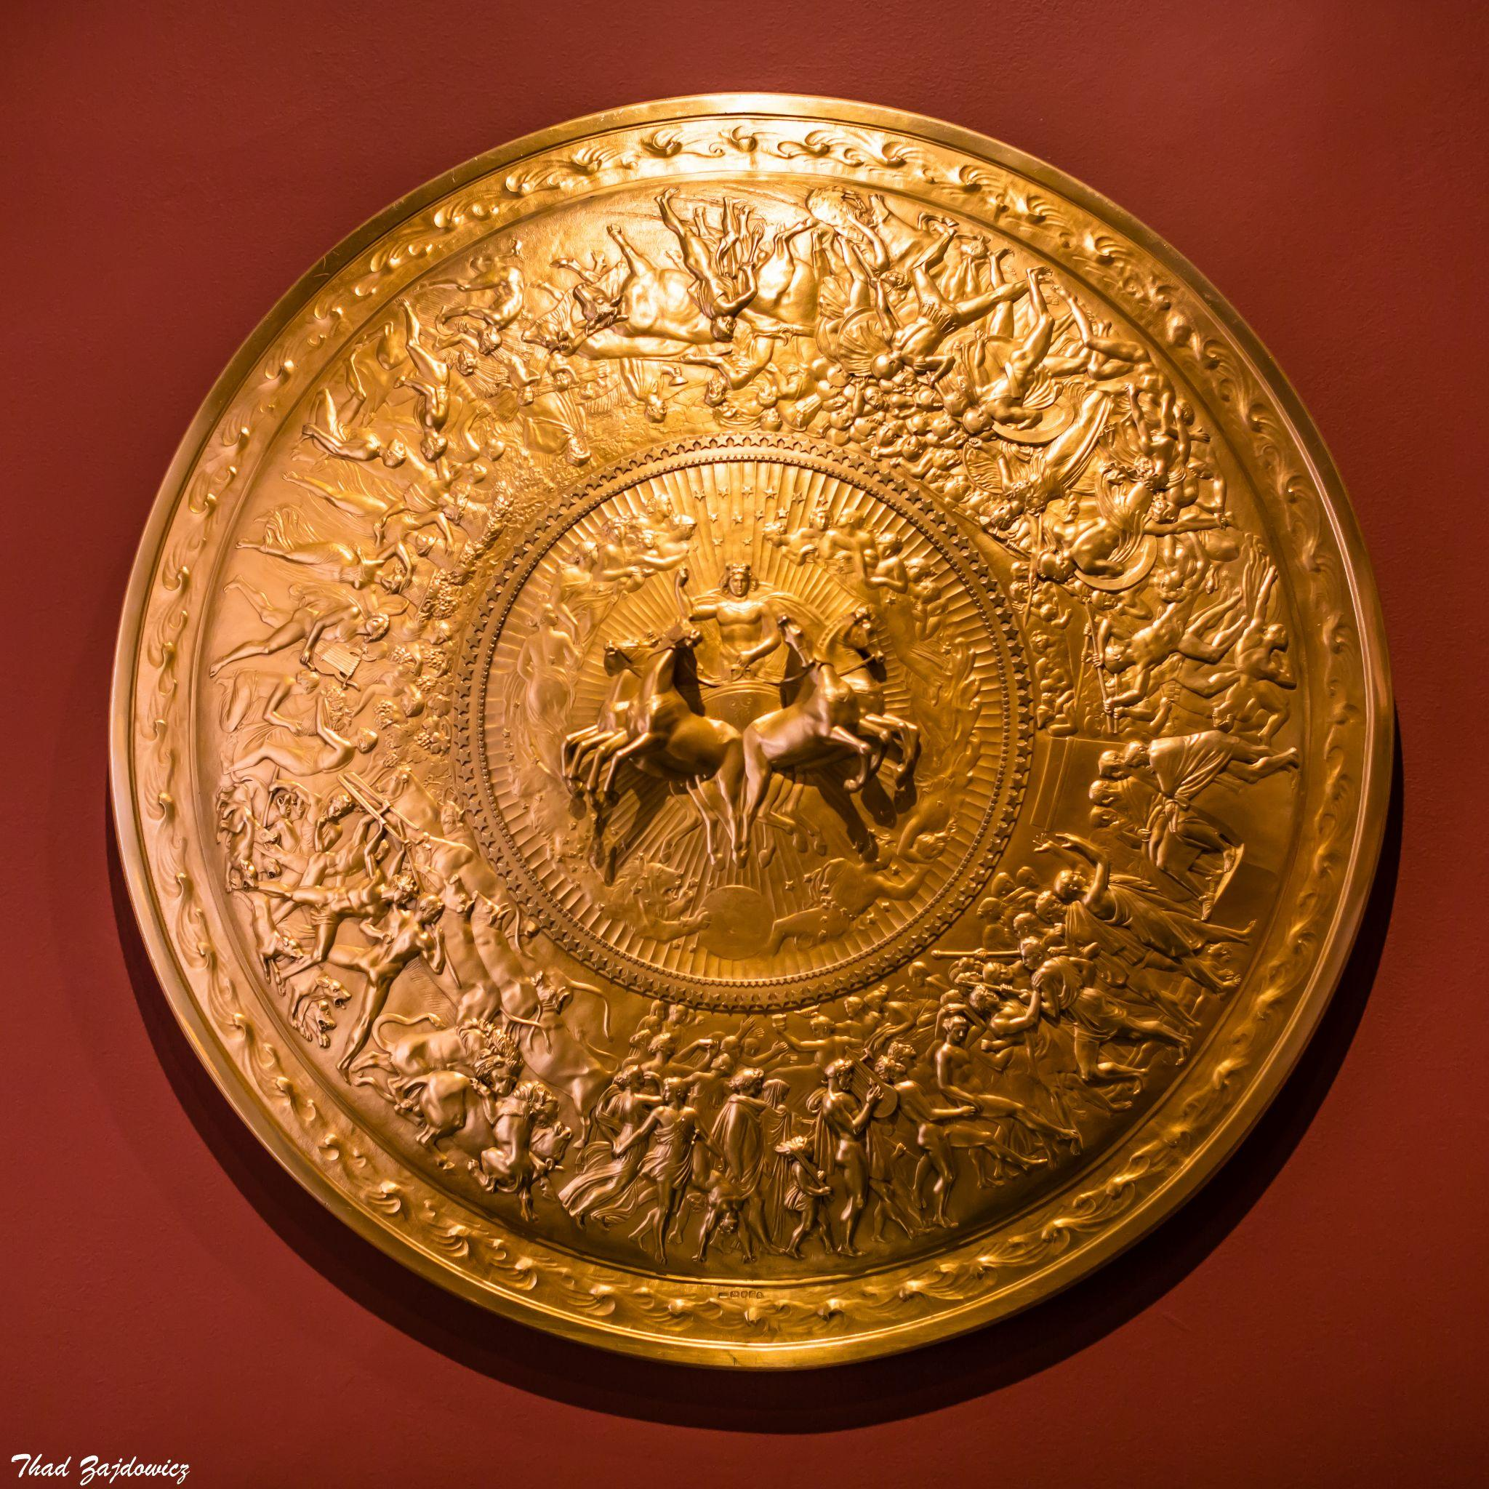

An alternative view of the entire shield, as captured by Thad Zajdowicz. Image is in the public domain and licensed under CC0 1.0 DEED CC0 1.0 Universal.

# [Further Information about the Artwork:](https://www.rct.uk/collection/51266/shield-of-achilles)

**Goldsmith:** Philip Rundell (1746-1827)

**Designer:** John Flaxman (1755-1826)

**Date:** 1821-22

**Medium:** Silver gilt

**Dimensions:** 90.5 x 90.5 x 18.0 cm

**Resides In:** [The Royal Collection Trust](https://www.rct.uk/), UK

Creative Commons License

This work is licensed under a [Creative Commons Attribution 4.0 International License](http://creativecommons.org/licenses/by/4.0/).